**MIDI on the MagicShifter3000**

The MS3000 is capable of functioning as a versatile MIDI platform. The MS3000 can use MIDI over Wifi (rtpMIDI) out of the box, but it is also prepared to be used as a hardware MIDI device as well.

To add MIDI Hardware capabilities (*) to the MidiShifter3000, one must wire up appropriate MIDI connectors. (Please note: some soldering required ...)

An easy way to do this is with the SparkFun MIDIShield:

<https://www.sparkfun.com/products/12898>

Here is a simple wiring guide:

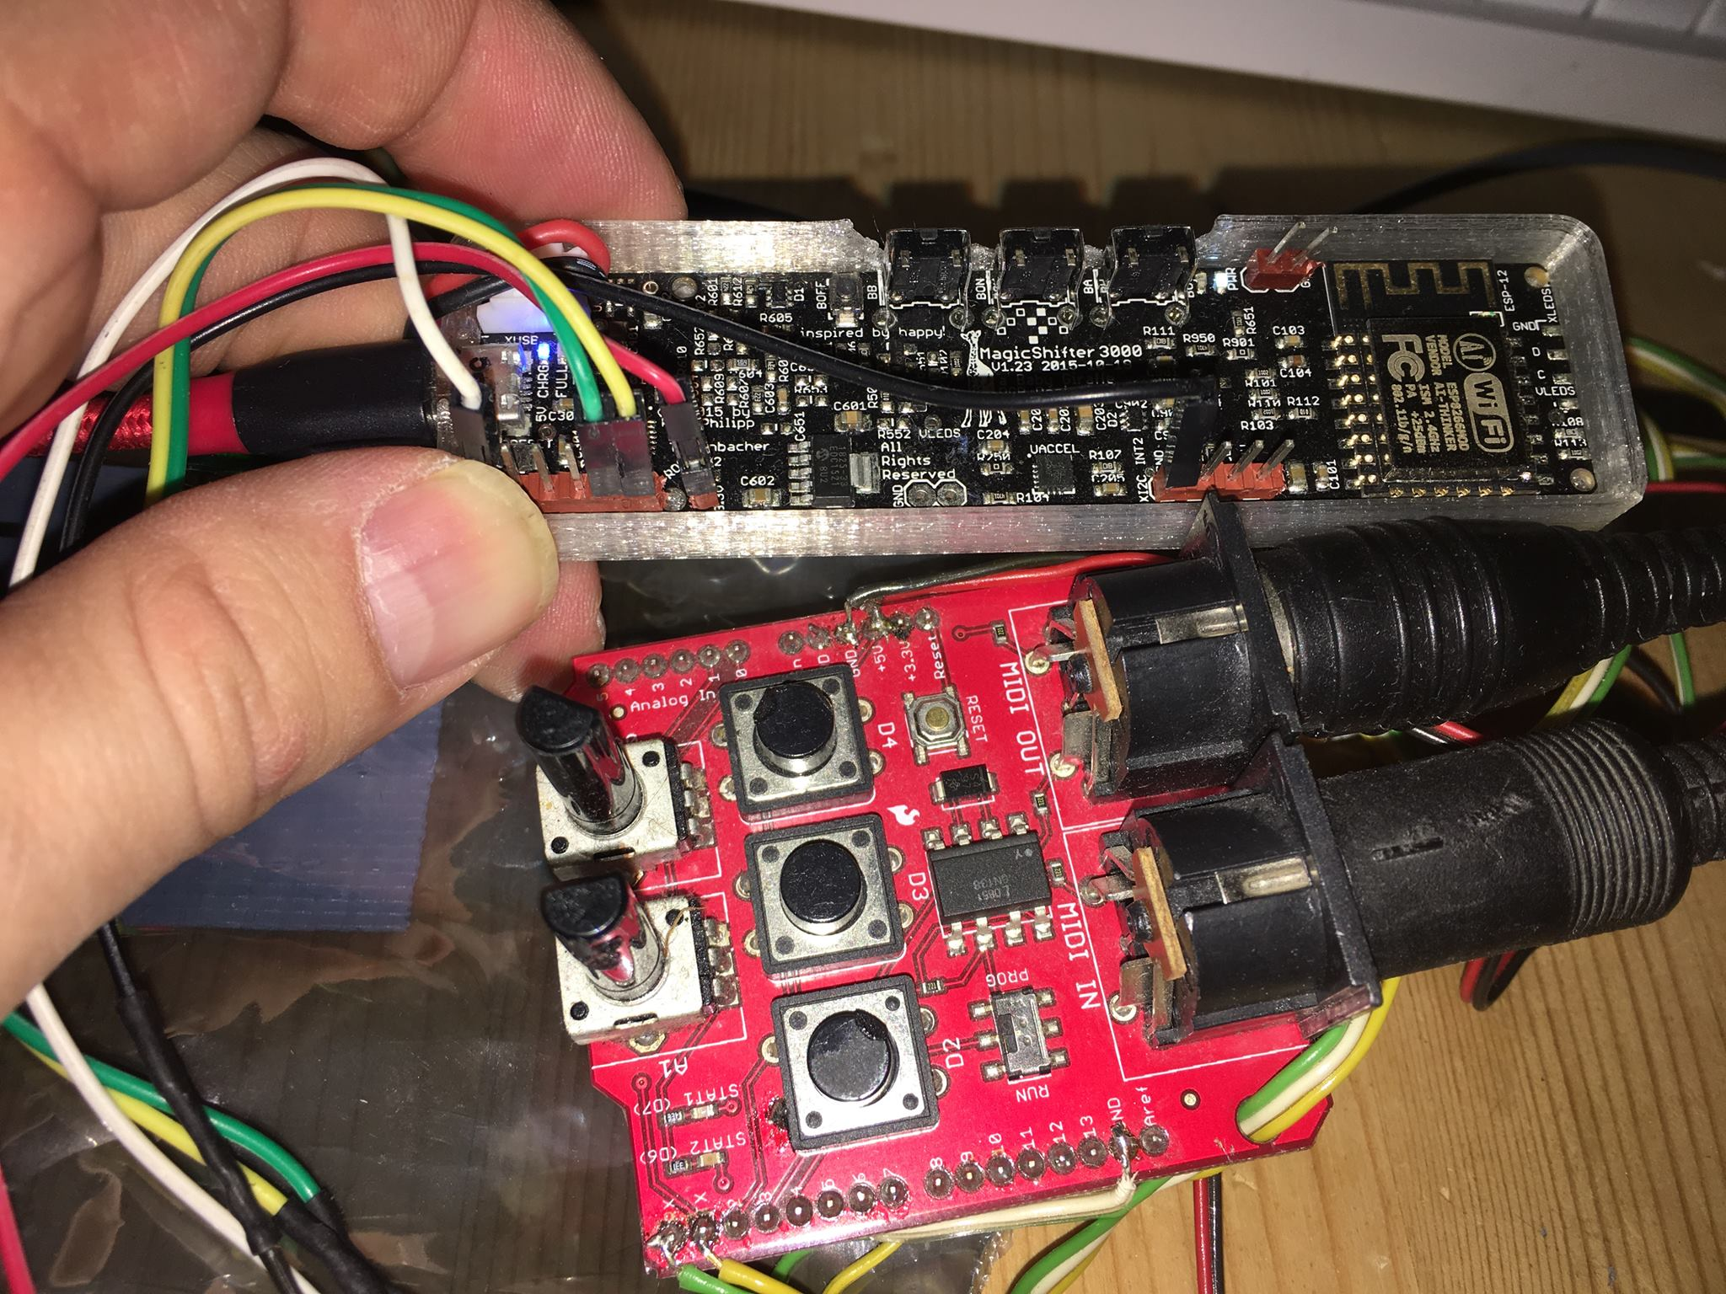

Pins on MS3000 (L to R), with cable colors for guides:  
  
MS3000 1: GND->GND on MIDIShield (WHITE)  
MS3000 5: TX->RX on MIDIShield (GREEN)  
MS3000 6: RX->TX on MIDIShield (YELLOW)  
MS3000 3v3->5v[bridged]3v on MIDIShield (RED)  
MS3000 GND->GND MIDIShield (BLACK)